**install and run Hive 3.1.2 on Windows 10**

**Download Apache Derby Binaries:**

Hive requires a relational database like Apache Derby to create a Metastore and store all metadata

Download the derby tar file from the following link:

[https://downloads.apache.org//db/derby/db-derby-10.14.2.0/db-derby-10.14.2.0-bin.tar.gz](https://downloads.apache.org/db/derby/db-derby-10.14.2.0/db-derby-10.14.2.0-bin.tar.gz)

Extract it to the location where you have installed Hadoop

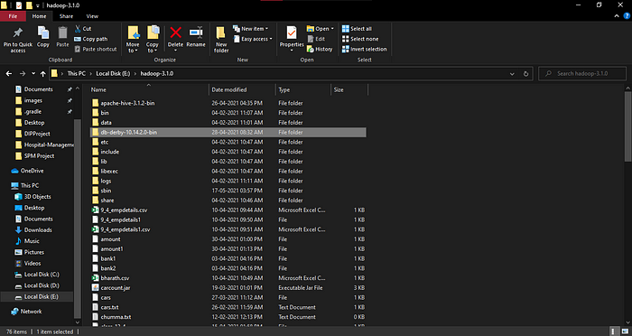

**2. Download Hive binaries:**

Download Hive binaries from the following link:

<https://downloads.apache.org/hive/hive-3.1.2/apache-hive-3.1.2-bin.tar.gz>

Extract it to the location where you have installed Hadoop

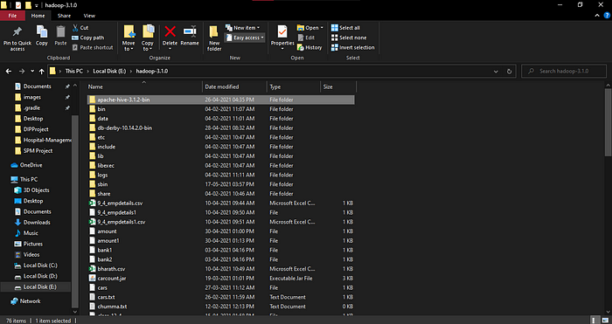

**3. Setting up Environment variables:**

Type ‘environment’ in Windows Search Bar

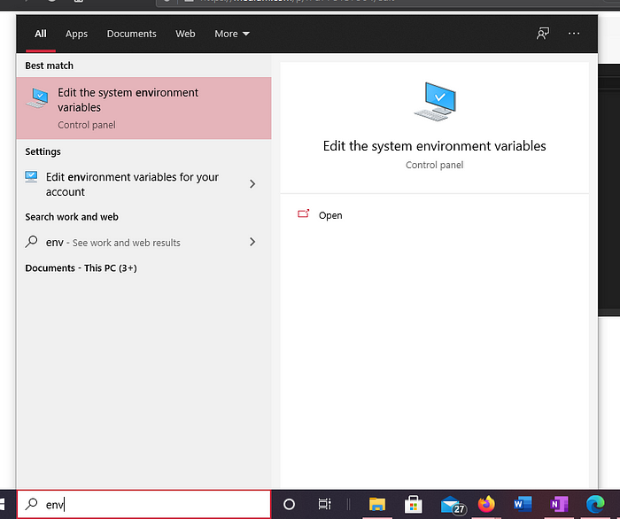

Click on Environment Variables

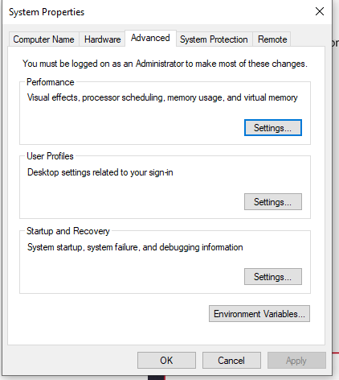

Click on New

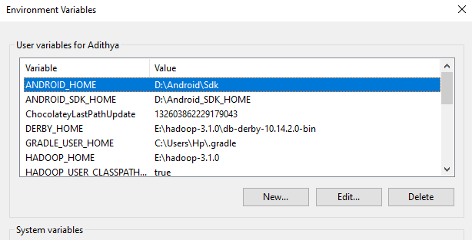

**Add the following variables:**

HIVE_HOME: E:\hadoop-3.1.0\apache-hive-3.1.2-bin

DERBY_HOME: E:\hadoop-3.1.0\db-derby-10.14.2.0-bin

HIVE_LIB: E:\hadoop-3.1.0\apache-hive-3.1.2-bin\lib

HIVE_BIN: E:\hadoop-3.1.0\apache-hive-3.1.2-bin\bin

HADOOP_USER_CLASSPATH_FIRST: true

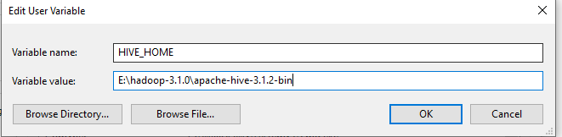

**In Path Variable in User Variables add the following paths:**

%HIVE_BIN%

%DERBY_HOME%\bin

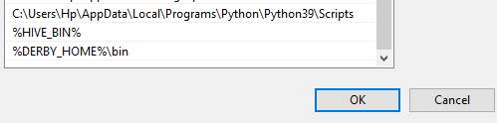

**Now in System Variables add the following:**

HADOOP_USER_CLASSPATH_FIRST: true

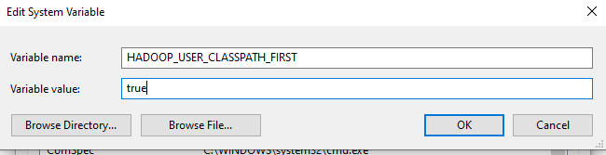

**4. Configuring Hive:**

**Copy Derby Libraries:**

Copy all the jar files stored in Derby library files stored in:

E:\hadoop-3.1.0\db-derby-10.14.2.0-bin\lib

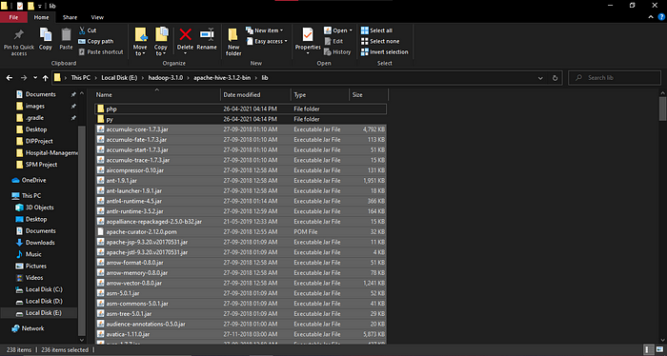

And paste them in Hive libraries directory:

E:\hadoop-3.1.0\apache-hive-3.1.2-bin\lib

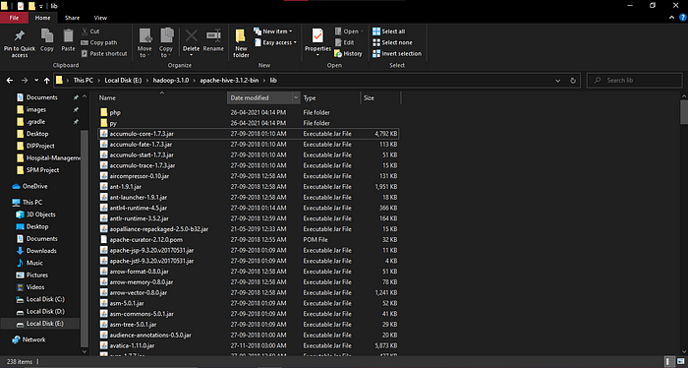

**5. Configuring Hive-site.xml:**

Create a new file with the name hive-site.xml in E:\hadoop-3.1.0\apache-hive-3.1.2-bin\conf

**Add the following lines in the file**

<?xml version=”1.0"?>  
<?xml-stylesheet type=”text/xsl” href=”configuration.xsl”?>  
<configuration><property> <name>javax.jdo.option.ConnectionURL</name>  
<value>jdbc:derby://localhost:1527/metastore_db;create=true</value>  
<description>JDBC connect string for a JDBC metastore</description>  
</property><property>  
<name>javax.jdo.option.ConnectionDriverName</name>  
<value>org.apache.derby.jdbc.ClientDriver</value>  
<description>Driver class name for a JDBC metastore</description>  
</property>  
<property>  
<name>hive.server2.enable.doAs</name>  
<description>Enable user impersonation for HiveServer2</description>  
<value>true</value>  
</property>  
<property>  
<name>hive.server2.authentication</name>  
<value>NONE</value>  
<description> Client authentication types. NONE: no authentication check LDAP: LDAP/AD based authentication KERBEROS: Kerberos/GSSAPI authentication CUSTOM: Custom authentication provider (Use with property hive.server2.custom.authentication.class) </description>  
</property>  
<property>  
<name>datanucleus.autoCreateTables</name>  
<value>True</value>  
</property>  
<property>  
<name>hive.server2.active.passive.ha.enable</name>  
<value>true</value> # change false to true  
</property>  
</configuration>

**6. Starting Services:**

**Start Hadoop Services:**

Change the directory in terminal to the location where Hadoop is stored and give the following command:

start-all.cmd

**Start Derby Network Server:**

Start the Derby Network Server with the following command:

StartNetworkServer -h 0.0.0.0

**Initialize Hive Metastore:**

Give the following command to initialize Hive Metastore:

hive --service schematool -dbType derby -initSchema

**Start Hive Server:**

hive --service hiveserver2 start

**Start Hive:**

**Start hive by giving the following command:**

hive

Installation Done